**WEEK-6:**

**ReactJS-HOL**

1. Here is the output after setting the environment for reactjs

* **Define SPA and its benefits:**

Single page application is a web application or website that interacts with the user and rewrites the current page and will not reload entire server i.e, all files are loaded only once.

* **Define React and identify its working:**

React is a javascript library and it is component based where the user interface is broken down into reusable pieces called components.

* **Identify the differences between SPA and MPA:**

**SPA:**1.

* **Explain Pros & Cons of Single-Page Application**

Pros:

Fast and responsive ,improved user interface can be used in any device maybe mobile or a desktop, code reusability and eaiser debugging like react.

Cons:

Initial time for load is longer, JavaScript must be enabled for proper functionality, can be complex for large app size.

* **Explain about React**

React is an open-source JavaScript library used for building user interfaces and React handles the rendering efficiently.

* **Define virtual DOM**

The **Virtual DOM**  is a lightweight JavaScript representation of the actual DOM (Document Object Model). React uses it to improve performance.

* **Explain Features of React**

**Component-Based Architecture:** Build encapsulated components that manage their own state.

**JSX:** JavaScript + XML syntax that makes writing UI code easier and more readable. **Virtual**

**DOM**: Faster and more efficient UI updates.

**One-Way Data Binding**: Predictable data flow for better control.

**Hooks**: Functional way to manage state and lifecycle.

**React Router**: Manage navigation in SPAs.

**High Performance**: Efficient DOM updates and re-rendering.

**Output:**

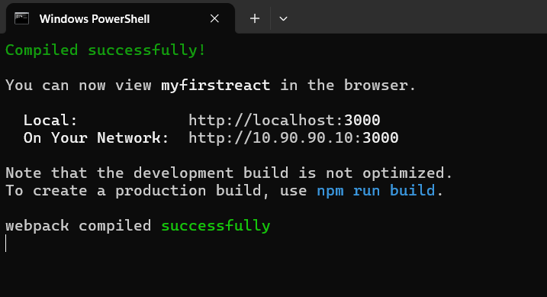

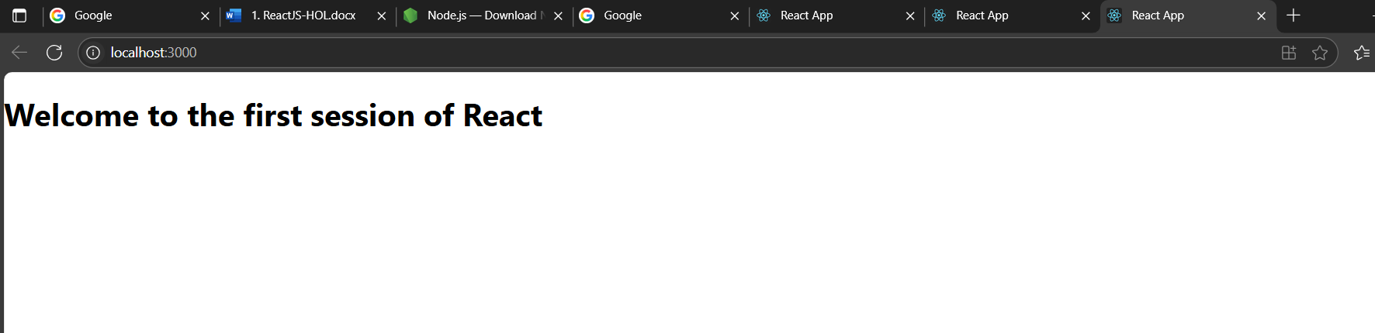

2.

Output:

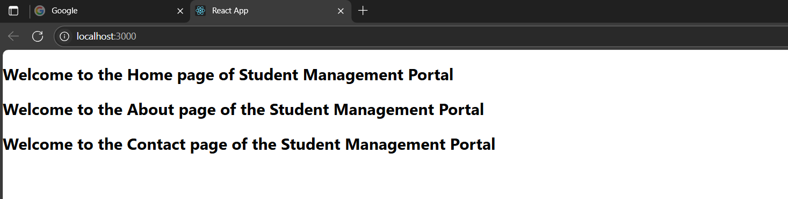

3.

Output:

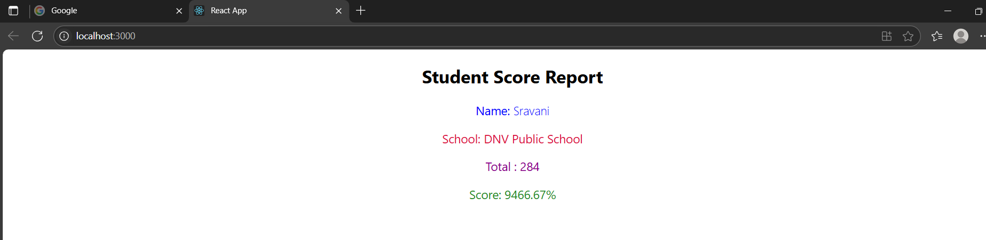

4.

Output:

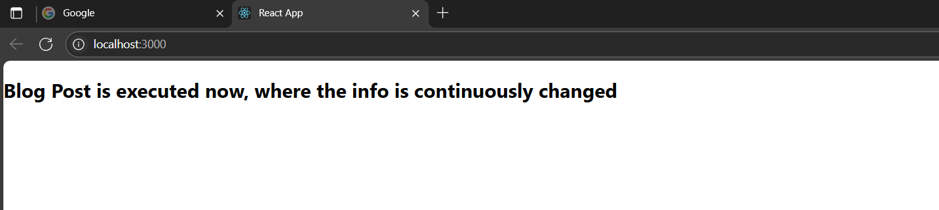

5.

Output:

